Copy editor notes:
• Photos approved
• Needs brand logo
• Grammar, punctuation, etc., changes below in red

Cover FX Custom Cover Drops

This post is sponsored by Cover FX, but all opions are my own, as per usual.

Here’s something you might not know about me: I didn’t wear any foundation until I was about 23 years old. Sure, I was able to hold out that long mostly because my skin was pretty much perfect (sorry, but don’t worry—that ended soon after), but it was also because I just hated wearing foundation. The few times I had tried using it, I felt like it was caked on, or it was flaky, or it made me look like I was “done up” too much, and even to this day I’m still really picky when it comes to my everyday foundation. It’s one thing when I have a photo or video shoot and the makeup has to be a little heaver—I’m fine with that—but I have two very important prerequisites when it comes to my daily face: It has to be light to medium coverage and it has to look like I’m not wearing any foundation at all.

I first heard about Cover FX Custom Cover Drops when they launched, and I was very intrigued by the fact that you can actually customize how heavy you want the coverage based on how many drops of the product you use.

I decided to use one of my favorite moistuizer (Please remove Brand & Hyperlink to Kieh’ls) as the base for my mixing, so I basically created an amazing foundation that’s not only super moisturizing but also has SPF 30 (!). The cool part about Cover FX Custom Cover Drops is that you can actually mix it with whatever face product you love—serums, moisturizers, primers…go crazy! The pigments in the Custom Cover Drops are coated with lecithin, which is biochemically similar to actual skin, to ensure seamless blending—hence, why it works so well.

Here’s the rule of thumb when crafting your foundation:
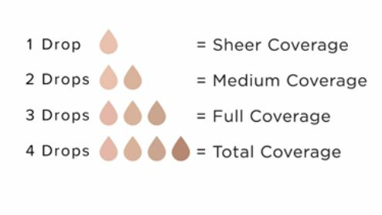
Step 1: Shake bottle and then drop your Custom Cover Drops into whatever mixer you like.
Step 2: Mix it up with your fingers or a foundation brush.
Step 3: Apply lightly and build it up on your face.

I added three drops (full coverage) for this particular day (since we were taking photos!), and I was incredibly impressed by how fantastic the Custom Cover Drops not only blended into my Kiehl’s moisturizer, but also into my face. Even though I technically had “full coverage,” it still looked incredibly natural and light. Next time I want to try mixing one drop into my sunscreen before I go to the beach, just for a hint of color to cover up any redness. I’m 100% sold on this stuff.

Seize your #Dropportunity with Cover FX

